**Saint Brigid Saint John the Baptist**

6th Sunday of Easter

May 6, 2018

**Catholic Church Catholic Church**

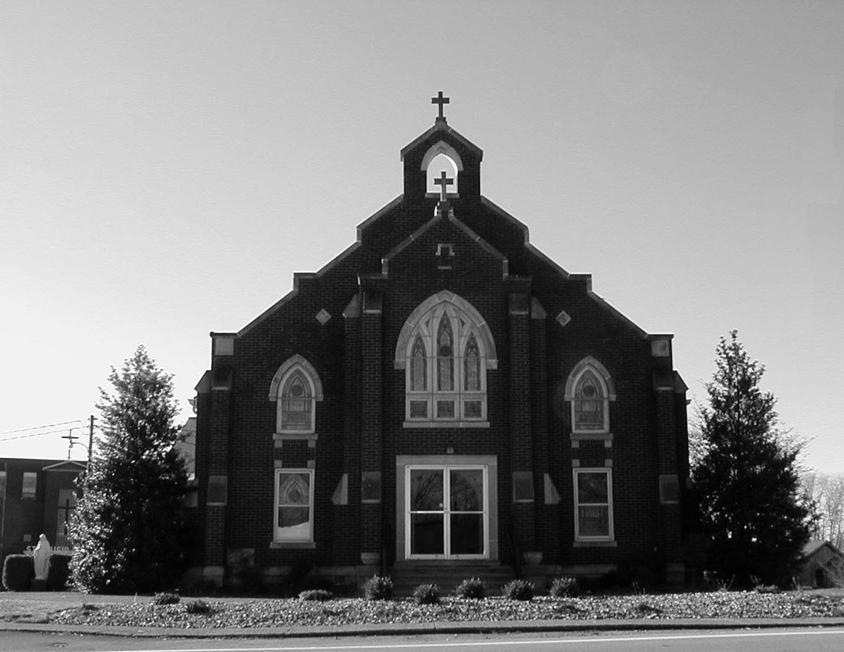

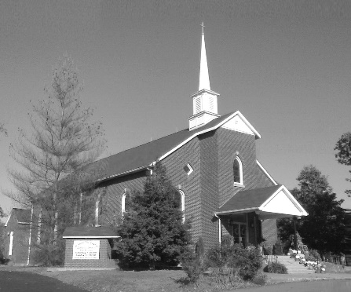

**Pastor:**

***Rev. Daniel L. Lincoln***

Rectory: (270) 877-2546

**Deacon:**

***Michael A. Ryan***

(270) 272-6789

314 E. Main St. 657 St. John Church Rd.

Vine Grove, KY 40175 Elizabethtown, KY 42701

Clustered Parish Office: Clustered Parish Office:

(270) 877-2461 (270) 877-2461

**ANNOINTING OF THE SICK:**

Notify the parish office when a family member is hospitalized.

**BAPTISM:**

Contact the parish office for information about the required preparation class.

**BULLETIN:**

Information must be submitted in writing by note or email to the parish office **no later than 12:00 noon on Wednesdays** for the following weekend. When sending an email, please put “BULLETIN,” and the name of the parish the announcement is for, in the subject line.

**MARRIAGE:**

Contact Father at least 6 months prior to the wedding date to complete required marriage preparations and to schedule the date.

**RCIA (Rite of Christian Initiation of Adults):**

Contact the Worship Chairperson for information.

**DEW MEMORIAL LIBRARY:**

(in St. Brigid Church basement):

Open: Sunday after 9:30 a.m. Mass& 45 minutes before all other Masses.

Email: [brigidvg@bbtel.com](mailto:brigidvg@bbtel.com)

Website:[www.stbrigidvg.org](http://www.stbrigidvg.org)

**Pastoral Associate & Dir. Dir. of Religious Education:**

**of Religious Education:** Lisa Thomas: (270) 735-6930

Deacon Mike Ryan: (270) 877-0546

**Youth Minister: Youth Ministers:**

Lori Law: (270) 723-0157 Angela Churchman:

(270) 268-9963

Ericka Finlay: (502) 612-2644

**MASS SCHEDULE:**

*Sunday:* 9:30 a.m. & 6:30 p.m.

*Monday:* 9:00 a.m.

*Thursday:* 9:00 a.m.

**RECONCILIATION:**

Sunday before Mass

5:30-6:00 p.m. or by appt.

**ROSARY:**

After weekday Masses

**PARISH COUNCIL MEMBERS:**

*President:* Sue Weisshaupt

*Vice-President:* Mike Bramlett

*Secretary:* Judy Cochran

*At-Large Members:* Blake Ryan

& Vincent Thompson

**CHAIRPERSONS:**

*Administration:* Dale Winchester

*Formation:* Tina Yates

*Parish Life:* Tom Billings

*Worship:* Keith Baughman

**MASS SCHEDULE:**

*Saturday (Vigil):*  6:30 p.m.

*Sunday:* 11:30 a.m.

*Wednesday:* 6:30 p.m.

*Friday:* 9:00 a.m.

**RECONCILIATION:**

Saturday before Mass

5:30-6:00p.m. or by appt.

**PARISH COUNCIL MEMBERS:**

*President:* Theresa Smith

*Secretary:* Karen Ray

**CHAIRPERSONS:**

*Administration:* Rick Newton

*Formation:* Ericka Newton

*Parish Life:* Bradley Wickersham

*Worship:* Nick Thomas



**Mass Schedule**

**Mass Schedule**

|  |  |  |  |  |  |
| --- | --- | --- | --- | --- | --- |
| **Saturday** | **May 5** | **6:30 p.m.** | **St. John** | **James “Mac” Thomas** | **Vigil: 6th Sunday of Easter** |
| **Sunday** | **May 6** | **9:30 a.m.** | **St. Brigid** | **Inge Luther, Cameron Ponder**  **& Luise Weisshaupt** | **6th Sunday of Easter** |
| **“** | **“** | **11:30 a.m.** | **St. John** | **For All Parishioners** | **“** |
| **“** | **“** | **6:30 p.m.** | **St. Brigid** | **Our Parish Family**  **Dickie Cecil** | **“** |
| **Monday** | **May 7** | **9:00 a.m.** | **St. Brigid** | **Wintermayr – Munz**  **Richard Hughes** | **Easter Weekday** |
| **Wednesday** | **May 9** | **6:30 p.m.** | **St. John** | **For Special Intentions** | **Easter Weekday** |
| **Thursday** | **May 10** | **9:00 a.m.** | **St. Brigid** | **Dickie Cecil** | **Easter Weekday** |
| **Friday** | **May 11** | **9:00 a.m.** | **St. John** | **In Thanksgiving** | **Easter Weekday** |
| **Saturday** | **May 12** | **6:30 p.m.** | **St. John** | **Anna Brangers** | **Vigil: Ascension Sunday** |
| **Sunday** | **May 13** | **9:30 a.m.** | **St. Brigid** | **Our Parish Family**  **Carlos Robbins** | **Ascension Sunday** |
| **“** | **“** | **11:30 a.m.** | **St. John** | **For All Parishioners** | **“** |
| **“** | **“** | **6:30 p.m.** | **St. Brigid** | **Billy Cecil** | **“** |

**INFORMATION FOR BOTH PARISHES**

**HAPPY EASTER!!** May the power of the Resurrection bring you joy, hope and peace throughout this Easter season! Fr. Dan and Deacon Mile.

**ABORTION AND ADOPTION –** The number of would-be adoptive parents (of newborn babies) far outstrips the supply in America. Each year in the United States, about 135,000 American children are placed for adoption. Experts estimate somewhere between one and two million couples seek to adopt yearly. Every year, there are about 1.3 million abortions. Sadly, only 4% of women with unwanted pregnancies give their children up for adoption. Every child is wanted and wanted desperately! By Pro-Life Articles Author [www.pro-lifearticles.org](http://www.pro-lifearticles.org)

**PROJECT RACHEL** **–** Healing…Forgiveness…Hope…After the experience of an abortion. If you or someone you know is struggling with the pain from an abortion, please consider Project Rachel – a post abortion ministry. To speak to someone confidentially, call (502) 471-2155 or email [ProjectRachel@archlou.org](mailto:ProjectRachel@archlou.org).

**CONFIDENTIAL PREGNANCY AND ADOPTION COUNSELING** – is available at Catholic Charities for women of all ages experiencing untimely pregnancies. A full range of services are provided, including adoptive placement, legal assistance and counseling for individuals, groups and families. Post-abortion counseling is also available. Services are provided regardless of income or marital status. For more information, call Catholic Charities at (502) 637-9786.

**66th ANNUAL REGIONAL CORPUS CHRISTI PROCESSION** – Fr. Jeff Hopper and the parishioners of St. Martin of Tours parish in Flaherty want to invite all clergy and lay members of the parishes of Hardin and Meade counties to the 66th Annual Corpus Christi Procession beginning at **3:00 p.m. on Sunday, June 3, 2018** at St. Martin of Tours Catholic Church, 440 St. Martin Road, Vine Grove, KY 40175.  Let’s bring back this regional tradition of processing in parish groups with banners.  All clergy are invited to vest (please bring albs and white stoles), and altar servers from all parishes are invited to serve and vest (bring own vestments please).  All parishes please consider bringing your Religious Orders, Knights of Columbus, first communicants, and any other groups or societies.  This is a great way to show our love for our Lord in the Most Blessed Sacrament and to increase faith in His Real Presence.  Deserts and refreshments to follow.  This year’s Celebrant and Homilist will be Very Reverend Martin Linebach, Vicar General and Pastor of St. James Catholic Church.

**SAVE THE DATE** – Fr. John Judie will have a celebration of his retirement, 70th birthday and 31 years of priestly ministry on **Saturday, August 11, 2018**. More details will follow later. He may be reached at (502) 774-5772.

**St. John and St. Brigid Prayer List**

To add someone to the prayer list, please call the parish office at (270) 877-2461. **Remember to call to remove someone from the list if they are no longer sick, etc.** *Please note that the prayer list has been revised. It is primarily for parishioners and their immediate family members*.

Helen “Dinky” (Cowley) **Adams**, Sam **Adams**, April **Allen**, Dennis **Arnold**, Barbara **Ashley**, Donnie Alan **Atcher**, Sue **Banks**, Shannon **Barnes,** Denise **Barnett**, Timothy **Birch**, Teresa **Laycock**, Charlie **Bowers**, Pauline **Brangers**, Ellen **Bryan**, Richard **Bryson**, Carol **Buchanan**, Jeremy & Margie **Buyer**, Deacon Bob **Caspar**, Sue **Caswell**, Ed **Cecil**, J. Mack **Cecil**, Harlan Ford **Clark**, John **Connor**, Betty Jo **Cooper**, Heidi **Correa**, Jeff **Craig**, Glynn **Clutches**, Roan **Dowell**, Karen **Dworshak**, Leroy **Embry**, Martha **Ford**, Dwayne **Garcia**, Carrie **Gribben**, Mary **Hager**, Mrs. Charles **Hair**, Stephanie **Hall**, Donnie **Hart**, Jimmy **Harper**, Bobby **Harris**, Debbie **Hodge**, Betty Lou **Jones**, Andrew **Kieta**, Olivia **Leasor**, Jenny **Leonhardt**, Jackie **Long**, Louise **Lucous**, Alma **Mahanna**, Shelly **Martin**, Shirley **Martin**, Martina **Masoni**, Don **Mattingly**, Gerard **Mattingly**, Paul Michael **Mattingly**, Mary **Medley,** Cindy **Miller**, Starla **Miller**, Doug **Osborne**, Duane **Osborne**, Mickey **Padgett**, Frank **Inanely**, Polly **Prather**, Annie **Pierce**, Adrianna **Porter**, Jeremy **Porter**, Adrian **Ray**, Allie **Ray**, Mary Agnes **Ray**, Mary Ellen **Ray**, James S. **Reed**, Sharon **Reed**, Tonya **Reisinger**, Joel **Rivera**, Caroline **Seabee**, Darlene **Staples**, Ralph **Staples**, Joan **Stith**, Keith **Tassin**, Kenny **Thompson**, Raffaella **Tucker**, Debi **Turner**, Charlotte **Vowels**, Bill **Waldrop**, Lois **Weaver**, Paul A. **Whelan**, Jennifer **Williams**, Sandy **Wiseman**, Zach **Wiseman**, Gail **Wilson**, Don **Wooldridge**, Connor **Wright**, Rose Marie **Yates** and all the sick.

* * * * * * * * * * * * * * * * * * *

**Our Military List**

To add someone to the military list, please call the parish office at (270) 877-2461. **Remember to call to remove someone from the list if they are no longer in the service**.

Lt. Matt **Bednar**, PFC Richard H. **Chapman**, A1C Aaron **Chandler**, A1C Brandon **Davila**, SrA Felicia **Esquivel**, PFC Tyler **Hall**, A1C Ryan **Henley**, A1C Joseph **Manco**, SPC Jacob L. **Nall**, SFC Peter **Novak**, Tony **Rickerl**, Lt. Col. Paul **Rigby**, 0James **Rogers**, Tony **Rogers**, Jonathon **Sifford**, Jeffrey **Slade**, Derek **Smith**, CSM Vance **Snider**, Brian **Tomassi**, A1C Daniel **Trombone**, SGT Evan **Vaughan**, PV2 William **Vaughan**, Lisa **Flynn-Veri**, LT Michael **Veri**, LTC Steve **Wickersham**, SGT Clay **Wilson**, TSGT Jeremy **Yates**, Austin **Zulka** and for all who serve and have served our country.

* * * * * * * * * * * * * * * * * * *

**ST. JOHN THE BAPTIST CATHOLIC CHURCH INFORMATION**

**Monthly Budget Amount Needed:** $ 12,500.00

**Monthly Collection for April:** $ 12,822.41

**WELCOME PACKETS** – If you would like to become a member, or learn more about St. John Parish, please take a *Welcome Packet* in the church lobby. You may return the census card and the stewardship form to Father Dan or place in the collection basket.

**THANKS** – to our parents and students for another year of Religious Education, and especially for the following teachers and substitutes for their gift of time, talent and treasure. Teachers: Jenny Bischoff, Vince Carlotti, Kim Compton, Angie Geer, Elaine Geer, Sharon Kennedy, Sara Kuhn, Abby Newton, Ericka Newton, Vicki Taylor and Clarissa Yates. Substitutes:  Angela Churchman, Terry Carlotti, Melanie Goode, Aimee Hunt, Rhonda Newton, Dayna Parrett, Tracie Price, Greg Thompson and Pam Yates. Enjoy your summer! Don't forget VBS in July and remember our faith is always with us so continue your spiritual journey till we meet again in the fall.

**BLESSING BAGS** – On behalf of Ericka, Angela, and the entire youth group we would like to thank each and every person that helped contribute to our Spring service project of the Blessing Bags. Whether you donated items or money, it was put to great use and we were able to compile 100 bags!! These were mostly distributed to schools in our community as we were made aware that the need was strongest there. The kids had so much fun putting together these bags and then adding a little note of encouragement or a Bible verse they liked. We will definitely do this again in the future and we appreciate your continued support of our Youth!

**ANOINTING OF THE SICK** – The Sacrament will be celebrated during the 6:30 p.m. Mass on **Wednesday, May 9.**

**STEWARDSHIP FAIR** – Mark your calendars for the upcoming Stewardship Fair. Before and after Mass on **Saturday, May 19 and Sunday, May 20.** We’re starting from scratch, so we are counting on everyone’s cooperation.

**PARISH COUNCIL** – will meet on **Monday, May 21, at 6:30 p.m.** in the Parish Hall.

**ALTAR SERVERS** – On **Sunday, May 27,** there will be an altar server practice immediately after the 11:30 a.m. Mass. This will be for all servers to improve their skills but primarily for new server candidates. Requirements for new servers are to have completed both 1st Communion, 1st Confession and be in 4th grade and up. Third Graders may be considered if the above requirements are met and with Fr. Dan’’s permission.

**SAVE THE DATE – VACATION BIBLE SCHOOL** – will be **Sunday-Thursday, July 15-19, from 6:00-8:30 p.m.** Make plans now for a great week! If you have any questions, contact Clarissa Yates, [cpyates@comcast.net](mailto:cpyates@comcast.net) or (270) 862-3792.

**FR. STAN OSBORNE** – can be reached at Nazareth Home, Room 112, 2000 Newburg Rd., Louisville, KY 40205.

* * * * * * * * * * * * * * * * * * *

**St. John Liturgical Ministers**

|  |  |
| --- | --- |
| **Vigil: 7th Sunday of Easter, May 12, 2018, 6:30 p.m.** |  |
| Extraordinary Ministers of the Eucharist | Becky Thomas Dennis Thomas Marcella Crewz |
| Lector | Joanna Sherrard |
| Servers | Volunteers |
| Greeter(s) | Ericka Newton |
| Gift Bearers | Tim Wiseman Family |
| - Ushers | John Thomas Kenny Heibert |
| **7th Sunday of Easter, May 13, 2018, 11:30 a.m.** |  |
| Extraordinary Ministers of the Eucharist | Lisa Parrett Jennifer Updegraff Libby Brangers |
| Lector | Richard Goode |
| Servers | Jose Santos Alex Powers |
| Greeter(s) | Pat Yount |
| Gift Bearers | Gail & Bobby Pike |
| Ushers | Kenny Leasor Doug Updegraff |

**ST. BRIGID CATHOLIC CHURCH NFORMATION**

**Monthly Budget Amount Needed:** $ 25,280.00

**Monthly Collection for April:** $ 34,228.18

**St. Vincent de Paul Society:** $ 526.00

**WELCOME VISITORS** – If you are interested in joining our parish, please pick up a Welcome Packet at the church doors. Complete the registration form and either drop it in the collection basket or mail it to the office. If you just need to update your registration, there are also forms available.

**WELCOME** – to the newest arrivals to our church family who will receive 1st Communion and Confirmation at the Easter Vigil: Crystal Yates, Emily Bohannon and John Williams.

**CONGRATULATIONS** – to Allie Ray who celebrated her 102nd birthday on May 2.

**PARISH DISCERNMENT** – The CORE TEAM members are: Nannette Johnston, Judy Cochran, Blake Ryan, John Jenkins, Suzanne Weisshaupt and John Tindall.

**SUMMER EVENT ENVELOPE** – Please turn in your Summer Event offering envelope. It should have been in your March envelopes. This helps us pay for the printing of the Summer Event tickets and the dinner tickets and a few other things. Should you have any questions, please contact Deacon Mike.

**KNIGHTS OF COLUMBUS APPALACHIAN MISSION** – Volunteers will be going again to the Appalachian Mountains to repair some houses at the end of May. The Mission Center we work out of is going through a restructuring process and is moving to a new address. This year due to their restructuring, we will not be taking any homewares. However, we would appreciate any donation of lumber and supplies. Make checks payable to the Knights of Columbus State Charities and mail to Charies E. Jones, 500 Milimish Rd., Vine Grove, Ky 40175. Thank you.

**FIRST COMMUNION – will be celebrated on Sunday, May 6, at the 9:30 a.m. Mass. Please keep the following communicants, and their families, in your prayers:**

Kaleigh Crabtree Holly Dinsmore

Ava Harper Gracie Russell

William Spencer

There will be a reception following Mass in the school meeting room. Should you need additional information, please contact Deacon Mike Ryan.

**ANOINTING OF THE SICK** – The Sacrament will be celebrated during the 9:00 a.m. Mass on **Thursday, May 10.**

**ST. BRIGID CONFIRMATION CANDIDATES 2018** – Please pray for the following candidates as they prepare to receive Confirmation on **Sunday, May 27,** at the 6:30 p.m. Mass:

Riley Bryant Michael Mayes

Breanna Davison Caraline New

Ridge Disselkamp Molly New

Reece Dowdell Nicholas Sanders

Morelia Falc’on Emily Savoni

Kyle Fowler Thomas Webb

Jaden Hicks Mollie Weisshaupt

**PARISH COUNCIL** – will meet on **Thursday, May 17, at 7:00 p.m.**

**SUMMER EVENT** – The Summer Event will be **Sunday, September 16**. That way we are not competing with St. Martin’s picnic or the Vine Grove Autumn festival. The lunch is from 1:00-3:00 p.m. The silent auction ends at 3:45 p.m. The main drawing will be at 4:00 p.m. Diane Taylor will cater the meal.  She can do a BBQ pork sandwich, baked beans, either claw slaw or potato salad, sweet and unsweet tea and, water.  She will also do a hot dog for children (or adults that don't want BBQ). We will have the food served in the new cafeteria.  We would still need teens to help serve drinks and bus tables and clean up like we do at the KC Hall now. The Summer Event Ticket Order Forms are at the side doors of the church and the table in the back of church. Should anyone need additional information please contact Teresa Morgan (270) 862-2909; Gina Ryan (270) 735-6355 or Deacon Mike Ryan (270) 877-0546 or (270) 272-6789.

**COMMUNION MINISTER UPDATE SESSIONS** – are for those ministers needing a mandate renewal, who have already completed the archdiocesan two-session Communion Minister Formation Program. This session will fulfill the requirements for continuing formation for Extraordinary Ministers of Holy Communion. I have scheduled the mandatory update session for **September 27, 2018 from 7:00- 9:00 p.m.** Please add to your calendar. I will put the form applications out three weeks before and make sure a new announcement gets into the bulletin. Should you have questions please contact Deacon Mike.

**Faith Formation**

**May** is the month of **Our Lady**. In honor of the Blessed Mother, St. Brigid will have her crowning on Mother’s Day, May 13, at the 9:30 a.m. Mass. Another celebration will be held on Sunday, May 20, following the 9:30 a.m. Mass in the form of coffee/donuts in the CMR followed by a DVD presentation of The Woman. This powerful, short (39 minutes) film presents the beautiful Catholic teaching about Mary, the mother of Jesus, and her important role in the Church and in the lives of Christians today. It combines images from classic sacred art with a soundtrack and explanations of the dogmas of the Mother of God, Immaculate Conception, Perpetual Virginity, the Assumption and other traditional beliefs/devotions to Mary.

Insightful commentary is provided on this DVD from several priests, a nun and a lay person, along with a number of young people speaking about their faith and love of Our Blessed Lady.

Please join your parish family in honor of Mary, our Mother!

**St. Brigid Youth Ministry**

**SENIORS** – Your RSVP is due for Baccalaureate by **Thursday, May 10**. Please contact one of the coordinators listed on the bottom of your invitation.

**Spring Picnic at the Fowler’s Home! Saturday, May 19** – Scott and Mary Fowler are opening their home for an evening of fishing, camp fire fun, outdoor games, relaxation, and so much more! This event will start at 6:00 p.m. and is open to all 8th-12th graders. **Please RSVP to Lori by the May 12.**

If you have any questions, please contact Lori at (270) 723-0157 or email at [stbrigidyouth@hotmail.com](mailto:stbrigidyouth@hotmail.com).

**St. Brigid Monthly Meet and Greet**

St. Brigid Parish hosts a “Meet and Greet” downstairs the 2nd Sunday of each month immediately following the 9:30 a.m. Mass with coffee and donuts. This is a great opportunity for existing parishioners to extend a warm welcome to visitors and anyone interested in joining St. Brigid Parish. Be sure to also visit the Dew Memorial Library. **No Meet & Greet on Mother’s Day, May 13, 2018**

**The next Meet and Greet will be Sunday, June 10, 2018.**

**St. Brigid Liturgical Ministers**

|  |  |
| --- | --- |
| **7th Sunday of Easter, May 13, 2018, 9:30 a.m.** |  |
| Extraordinary Ministers of the Eucharist P. | Helen Hicks Nancy Kotarski |
| C. | Gary Morris Patty Sims Sherleen Barren Rose Cooper |
| Lector | Tina Yates |
| Servers | Emily Chandler Cal Yates |
| Greeters | Chris & Janet Kennedy Tina Yates |
| **7th Sunday of Easter, May 13, 2018, 6:30 p.m.** |  |
| Extraordinary Ministers of the Eucharist P. | Jim Weed |
| C. | Keith Baughman Kim Osterhage |
| Lector | James Weed |
| Servers | Volunteers |
| Greeters | Volunteers |
| **Hospital Ministry – Sunday, May 13, 2018** | James & Julie Weed |

***Marriage Moments*** –

On May 10, Christians celebrate Jesus’ Ascension into heaven 40 days after Easter. But what does it mean to ascend into heaven? What does it mean to watch a beloved spouse leave for another life after death? These are heave things to ponder. Talk with your spouse about what you believe about an afterlife.

***Parenting Pointers*** –

In March families were challenged to unplug for a day. This is Screen Free Week. Ask your family if they are willing to free themselves of digital devices (with the exception of work or school) for one full week. Experiment with human or outdoor entertainment.